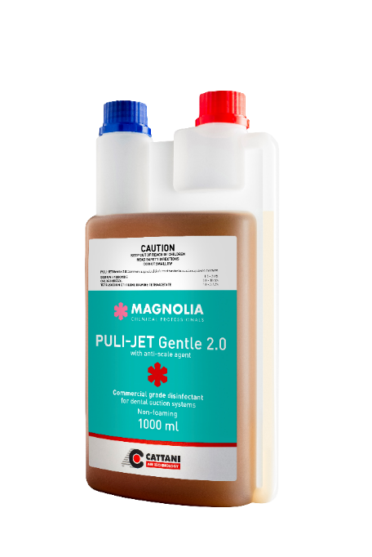
PULI-JET Gentle 2.0
Non-foaming disinfectant for dental suction systems

PULI-JET Gentle 2.0 is an anti-microbial solution from our Magnolia range, specifically made to disinfect dental suction devices, known for its easy-to-remember single dilution disinfecting procedure.

New Improved Formula:

- Phenol Free
- Aldehyde Free
- Lemon Fresh Scent

NO alternating schedules,
NO alternating products or dilutions,
NO suction system line shock treatments are needed.

PULI-JET Gentle 2.0 is available in 1-litre bottles, equal to 33 cleaning procedures.

______________________________________________________________
Why choose PULI-JET Gentle 2.0?

It is not often that a company would set up an entirely separate entity dedicated to serving its original purpose. At Cattani, we established Magnolia Chemical Professionals, an independent company fully committed to improving the performance of Cattani equipment and protecting its users through infection control.

For more than 50 years, we have refined our skills painstakingly to specialise in one thing only – premium air technology.

The ultimate defence system

PULI-JET Gentle 2.0 was designed to help protect:
- Patients
- Staff who use the suction system
- Contractors who perform system maintenance on your plant room equipment
- Amalgam recycling contractors
- Dental suction systems.
For best practice in dental suction system infection prevention and control.

